Kathy Charman
Birtley House School
February Newsletter 2022
Thank you to everyone who sent kind wishes and thoughts about Kathy’s sudden death. Many of you have asked us if you can make a donation on behalf of your child. Kathy’s family have now given details of two charities dear to her and they are asking for donations instead of flowers at her funeral later this month. These are:
We Are Beams
wearebeams.org.uk (Kathy and her husband used to provide respite care for families)
and
Willow Wildlife Rescue
http://willowwildlife.co.uk a small local charity looking after animals which Kathy was passionate about.
Please feel free to donate if you so wish.
Summer School 2022
Our Summer School event in August 2021 was a fantastic success. The children enjoyed a variety of activities including table tennis, badminton, cookery and craft. We are offering our summer school next year at the same price of £150 for the week Monday 1st to Friday 5th August 9am-3pm. No part places are available I’m afraid. If you want to secure your place on this event please inform the office and transfer £50 online to the school account. Places were popular last year so don’t miss out!
Summer School 2022 Monday 1st- Friday 5th August
(Your place can be secured with a £50 deposit)
Bank Details – Lloyds TSB – Sort Code – 30:93:60 Account Number – 30279168
Covid
Please continue to lateral flow test your child twice a week before sending them to school so we can pick up cases with no symptoms and protect others. Also, if your child has a heavy cold, please keep them at home to avoid spreading germs around.
Sensory Garden
Thank you to our wonderful PTA for raising money for our sensory garden. Groundwork begins in April and we can’t wait to raise more funds to add the fun bits!

Class Activities

Here are activities we have been doing in some classes this month:

Badgers and Bats Class have been learning how to do street art graffiti.
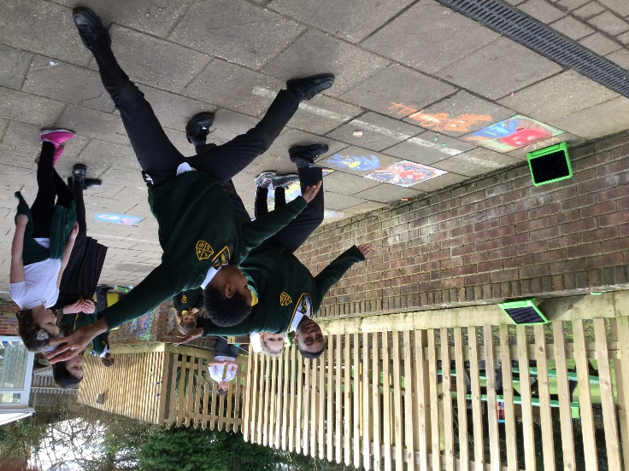
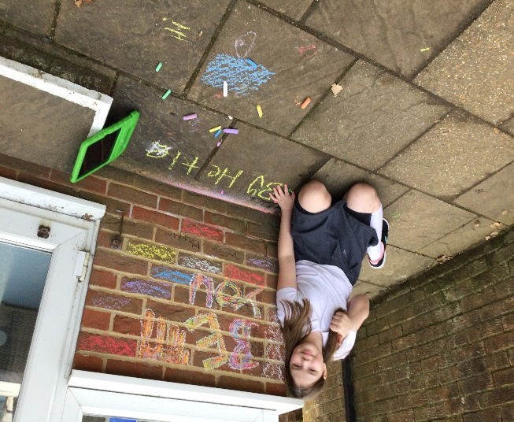

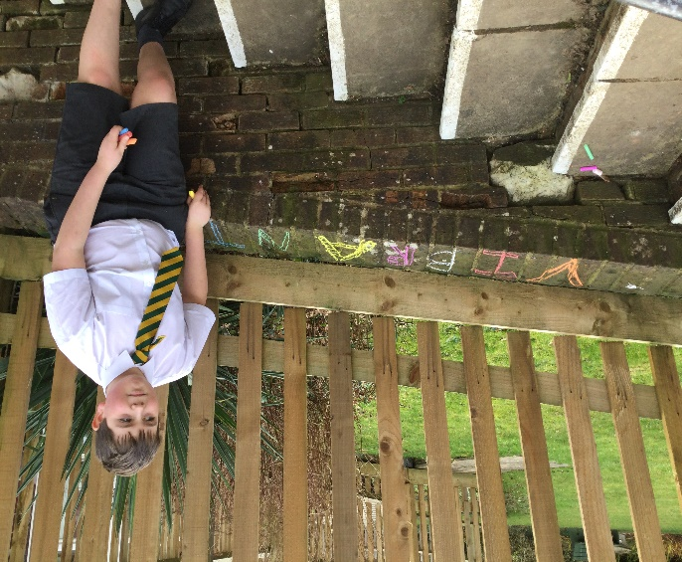
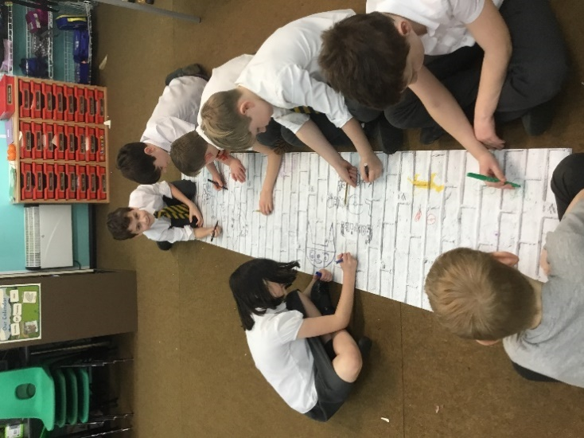

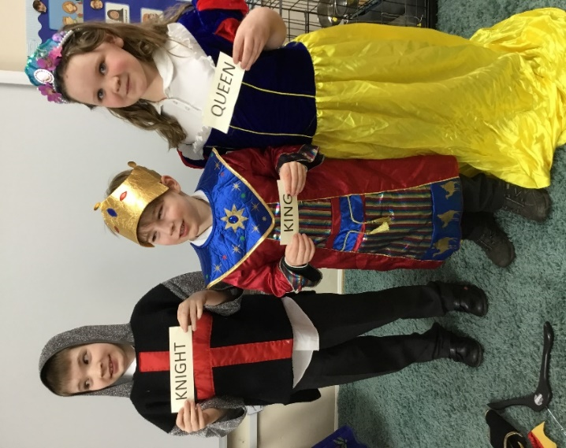
Rabbits Class have been learning about Castles and enjoyed dressing up as medieval characters.

They have also been learning how peasants lived and made houses to show this.

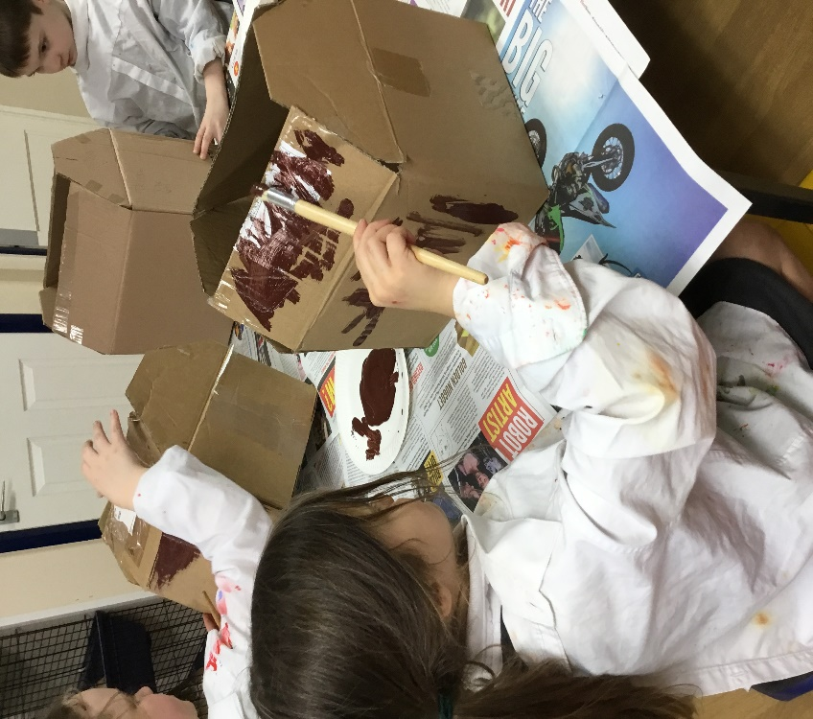

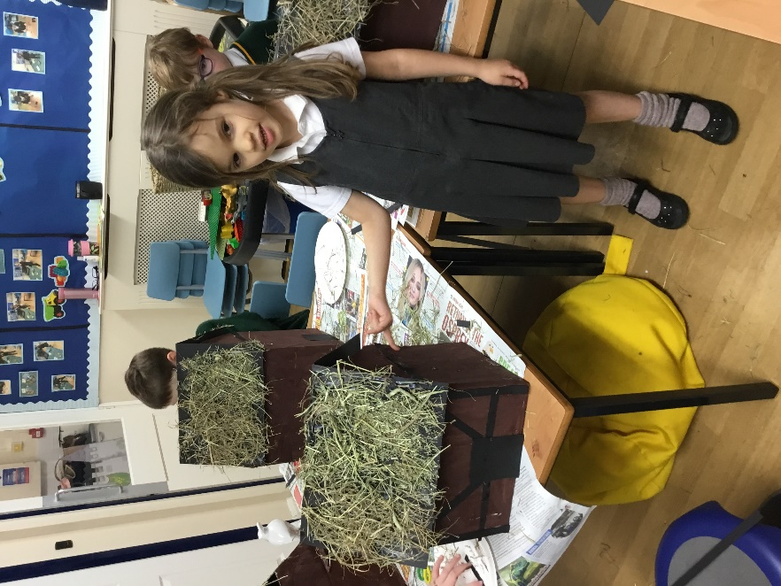

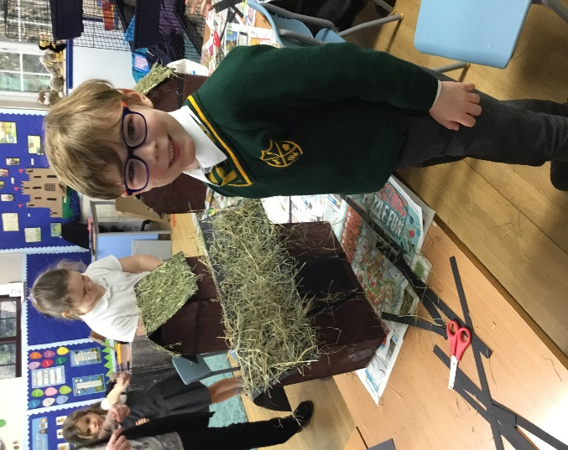

The children in Owls Class have been conducting a science experiment where they compare weights of different objects and even testing the weight of air.
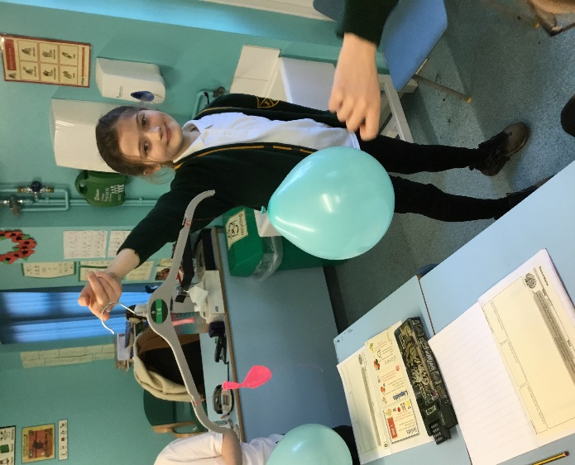
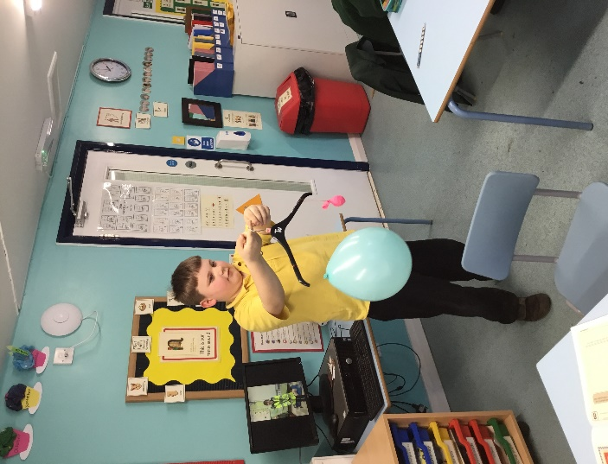

Enjoy your half term holiday everyone!

Mrs Sillitoe

Diary Dates:

- February Half Term
Monday 14th- Friday 18th February
- Swimming lessons start date – Wednesday 23rd February (other children will be doing PE in school)
- Bowles Trip Years 5/6 - 27th -29th April
- Class Photos 26th April

