Staffing
Birtley House School
October Newsletter 2021
Congratulations to Miss Emily Whitehead who has been promoted to the role of Assistant Headteacher. This is a reflection on her dedication and incredible commitment to the school over the last four years.
Please note that the Senior Leadership Team of the school is as follows:
Headteacher: Mrs Emma J Sillitoe
Deputy Headteacher: Mrs Ellie Austin
Assistant Headteacher: Miss Emily Whitehead
Mrs Berry is moving on to pastures new after three years working at Birtley. We wish her all the best in her new job. Her role as TA in Bats class will be taken on by Mrs Francis and Miss Tennant who are already very well known to the children.
We are delighted to welcome a new Occupational Therapist, Abbie Hancock. She will be working in addition to Sharon Gillard to expand our OT Team.
We are also very happy to welcome Kathy Charman, our very experienced specialist social skills and language teacher back after a period of leave. She will be working one day a week taking social skills interventions.
Summer School 2022
Our Summer School event in August 2021 was a fantastic success. The children enjoyed a variety of activities including table tennis, badminton, cookery and craft. We are offering our summer school next year at the same price of £150 for the week Monday to Friday 9am-3pm. No part places are available I’m afraid. If you want to secure your place on this event please inform the office and transfer £50 online to the school account. Places were popular last year so don’t miss out!
Summer School 2022 Monday 1st- Friday 5th August
(Your place can be secured with a £50 deposit)
Bank Details – Lloyds TSB – Sort Code – 30:93:60 Account Number – 30279168
Colds / Covid
If your child has cold symptoms please give them a lateral flow test before sending them to school. If the cold is very heavy please keep them at home to avoid spreading germs around.

Sensory Garden
Thank you to our wonderful PTA for raising money for our sensory garden. We are beginning work next April (mainly ground works) and we need to continue to fund raise to be able to afford items to put in it!! We need at least another £4000.
Class Activities
Here are activities we have been doing in some classes this month:
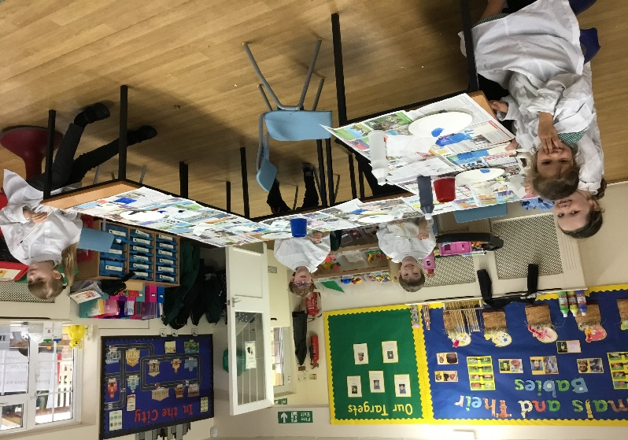
Rabbits class have been learning about different shades of colour and light and dark using paint.
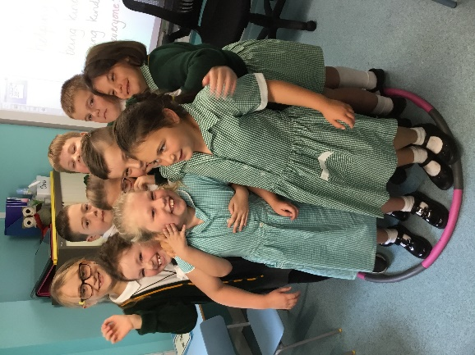
Problem solving and team skills in Owls Class.

Diary Dates:
October Half Term
- Monday 25th - Friday 29th October 2021
Christmas Plays (at Eynsford Village Hall)
- Thursday 9th December 2pm
- Friday 10th December 2pm

