
Birtley House School
March Newsletter 2022
Mrs Webb is leaving
After eleven years at Birtley House School, and many more in education, Mrs Webb has decided to make a career change. There are not enough words for me to express what Mrs Webb has contributed to the school. In the early years she even taught a lesson during an Ofsted Inspection and achieved an Outstanding Grade and she has contributed hundreds of brilliant ideas to the development of the school especially in supporting the pastoral welfare of pupils. We will desperately miss her and wish her every best wish in her new career!
We have employed a new Office Manager, Sarah Whelan who will be starting after Easter working alongside Mrs Strong and we know you will give her a warm welcome.
Trips
We are really happy that we are now able to start doing more trips out. See diary dates at the end of this newsletter. We are planning a lot more for the summer term. Watch this space!!
Summer School 2022
Our Summer School event in August 2021 was a fantastic success. The children enjoyed a variety of activities including table tennis, badminton, cookery and craft. We are offering our summer school next year at the same price of £150 for the week Monday 1st to Friday 5th August 9am-3pm. No part places are available I’m afraid. If you want to secure your place on this event please inform the office and transfer £50 online to the school account. Places were popular last year so don’t miss out! Summer school will be staffed by Mrs Sillitoe, Miss Whitehead, Lolly Sillitoe and some other staff.
Summer School 2022 Monday 1st- Friday 5th August
(Your place can be secured with a £50 deposit)
Bank Details – Lloyds TSB – Sort Code – 30:93:60 Account Number – 30279168
Covid
You no longer need to test your child with LFTs (according to legislation) however you are very welcome to continue to do so if you wish as it is still sensible to know if your child or a family member has covid and to keep your child at home if they test positive. We have spare tests in school so if you need some please ask the office so send a box home.

isandbox
The PTA are funding an amazing interactive sandbox with forty different programmes covering a range of curriculum areas. We trialled one over a year ago and the children absolutely loved it so we are super excited about having our own.
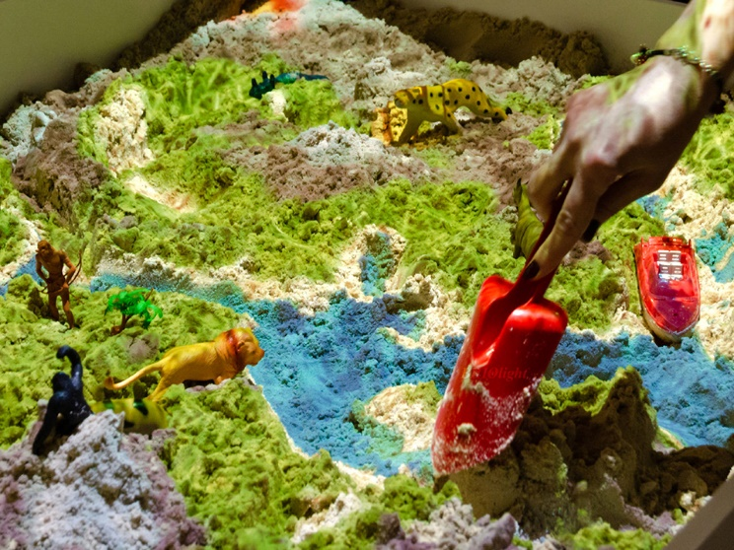
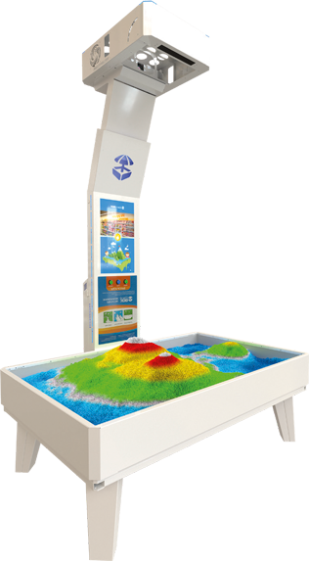

Class Activities
Here are activities we have been doing in some classes this month:
Owls Class took part in an Anglo Saxon workshop and greatly enjoyed themselves.
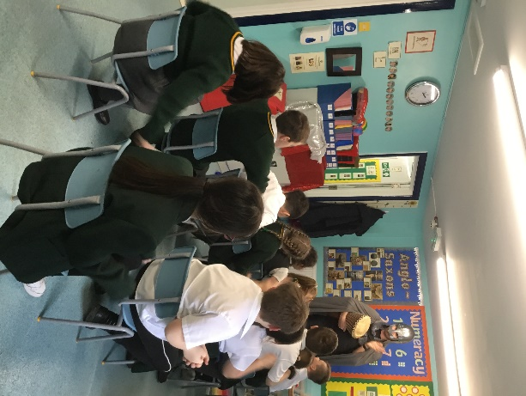
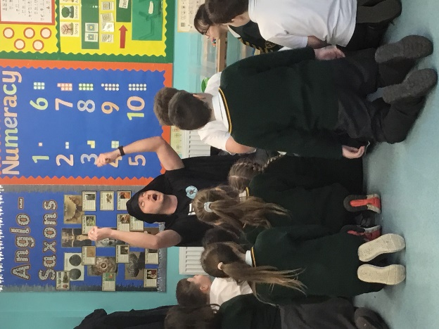
Bats Class have been learning about shadows in science.

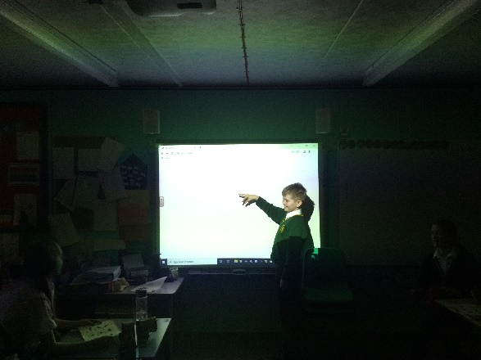
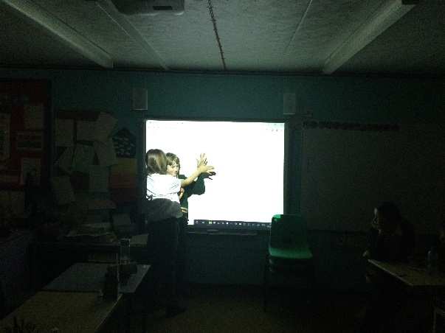

Rabbits Class have been making seed pictures in science and dressing up as their favourite world book day characters.
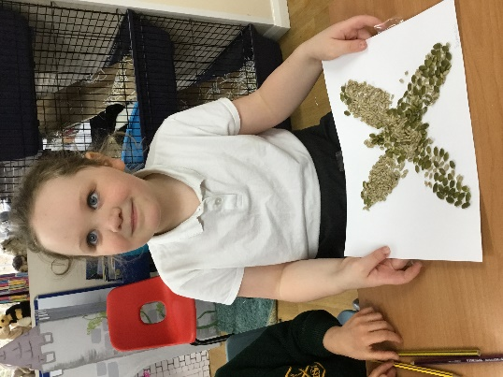
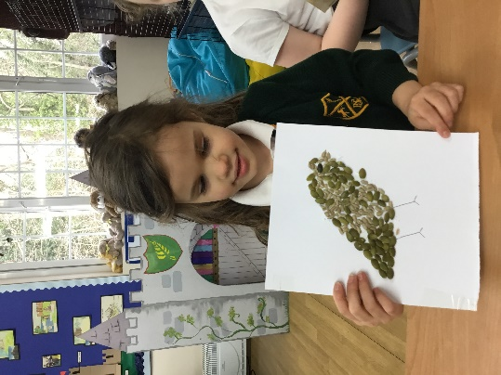
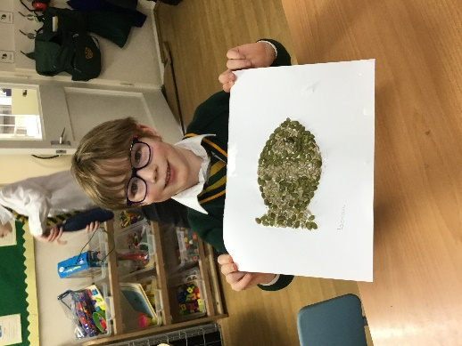

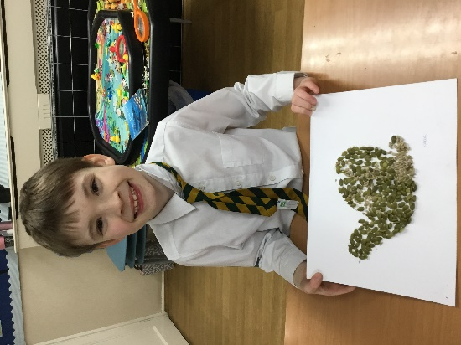
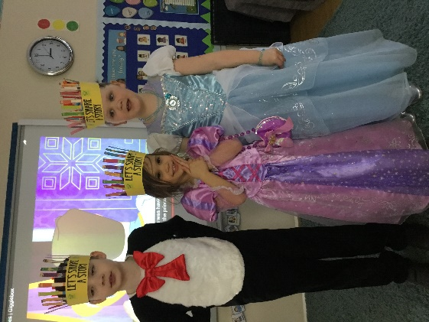

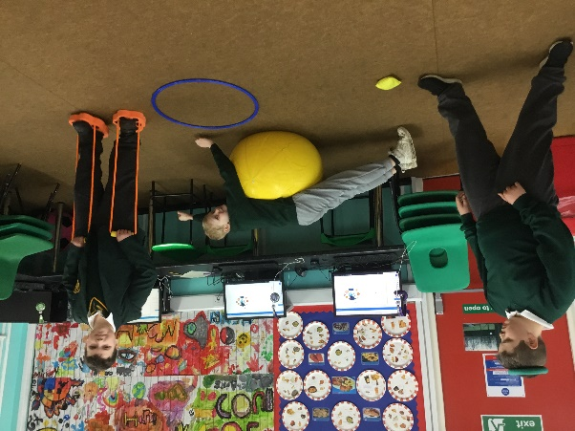
Badgers Class have been enjoying their sensory circuits sessions.
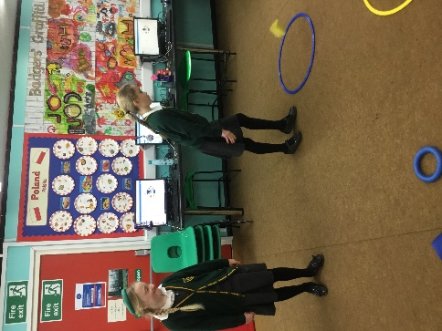
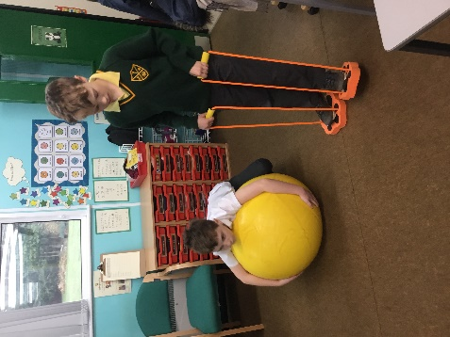
Online Safety
It’s a Jungle Out There! A BAO (Be Aware Online) game ‘The jungle, like the internet, is a happy and colourful place, where you can you meet up with friends, take photos and share what you discover and finally find out new things. However, the jungle can be a dangerous place full of strange and mysterious things and unpredictable events.’ Buckinghamshire Council have launched an online safety game ‘Bao – It’s a Jungle out There!’; developed with Special Schools and their EU partners (UK, Sweden and France) as part of a project aimed at sharing good practice and identifying the best ways of addressing how to keep children and young people safe online.
The SEN Stay Safe Project can be played either in a class setting or at home and aims to give teachers and parents the confidence and resources to discuss and equip young people with Special Educational Needs the knowledge and skills around internet safety and the implications of technology in their everyday lives. Links to the game along with the guidance document, including lesson plans and conversation starters can be found at here.
https://schoolsweb.buckscc.gov.uk/equalities/erasmusplus-projects/stay-safe-internet-safety-for-sen/
Enjoy your Easter holiday everyone! See you back in school on Tuesday 19th April
Mrs Sillitoe
Diary Dates:
- Last day of Spring Term Thursday 31st March at 2pm
- Monday 21st March – Badgers Art Trip to Eynsford
- Wednesday 23rd March – Mrs Austin’s Social Skills Trip to Bluewater
- Thursday 24th March – Miss Whitehead’s Social Skills Trip to Bluewater
- Monday 28th March – Rabbits History Trip to Hever Castle
- Tuesday 29th March – Mrs Sillitoe’s Social Skills Trip to Bluewater
- Wednesday 30th March – Easter Egg Raffle
- Bowles Trip Years 5/6 Activity Week (Rest of School) - 27th -29th April
- Class Photos 26th April
- Sports Day at Brands Hatch – Thursday 7th July

