Welcome Mrs Whelan!
Birtley House School
May Newsletter 2022
Welcome to Mrs Whelan as our new Office manager working alongside Mrs Strong. She is doing a fantastic job. Thank you to everyone who has made her feel very welcome.
Bowles Trip
Years 5 and 6 took part in a fantastic residential trip at Bowles Activity Centre at the end of April. All the pupils overcame their fears and achieved wonderful feats of daring as well as learning teamwork and independent skills. Some children will return again next year to build on their skills and we look forward to taking our current Year 4 children next year!
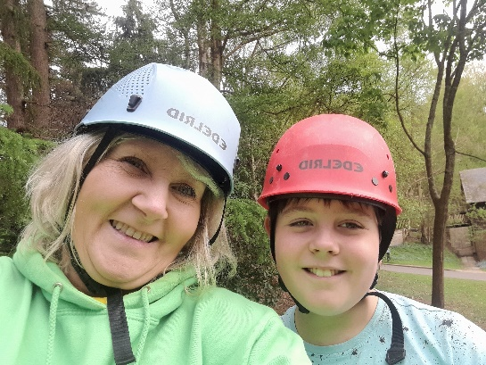
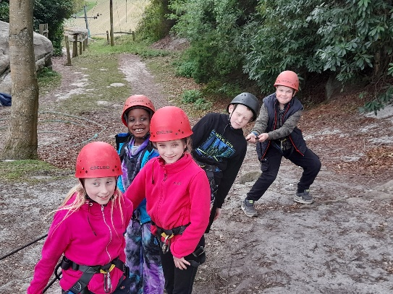
Activity Week
Whilst the older children were at Bowles the rest of the school had a fabulous week visiting Eagle Heights, making pizzas and going to Dinotropolis! The experience at Eagles Heights was truly wonderful, learning about the animals and making friends with the huskies. Thank you to Archie’s Mum for making this possible for us!
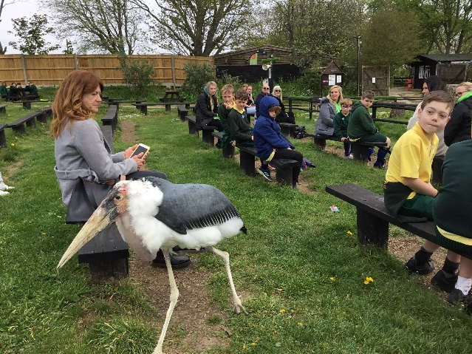
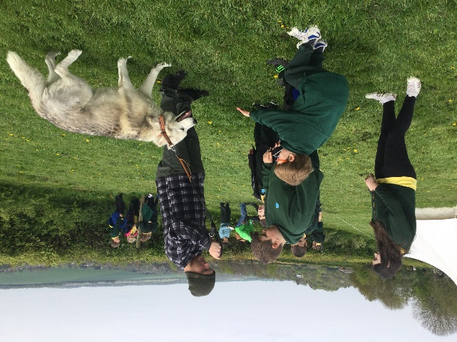

Summer School 2022
Our Summer School event in August 2021 was a fantastic success. The children enjoyed a variety of activities including table tennis, badminton, cookery and craft. We are offering our summer school next year at the same price of £150 for the week Monday 1st to Friday 5th August 9am-3pm. No part places are available I’m afraid. If you want to secure your place on this event please inform the office and transfer £50 online to the school account. Places were popular last year so don’t miss out! Summer school will be staffed by Mrs Sillitoe, Miss Whitehead, Lolly Sillitoe and Nick Wright.
Summer School 2022 Monday 1st- Friday 5th August
(Your place can be secured with a £50 deposit)
Bank Details – Lloyds TSB – Sort Code – 30:93:60 Account Number – 30279168
Bikeability
Some Year 5 and 6 children took part in this brilliant event last week and it was a super success. All the children gained in confidence and cycling skills and they will be much safer and more competent cyclists in the future. Well done to everyone who took part!
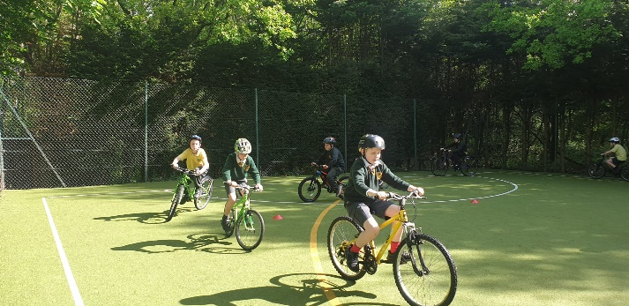
Summer Fair - Friday 24th June
The Summer Fair will take place on the above date on a normal school day. This is so that every child can take part and it is a fully inclusive event. We will be circulating more details soon.

Father’s Day Stall - Friday 17th June
The PTA will send out more details about this soon.

Mrs Sillitoe

Diary Dates
- Monday 16th May – Rabbits Class – Trip to Howletts
- Monday 16th May – Bats/Badgers Classes – In A Nutshell The Victorians (in school)
- Friday 20th May – Celebration of Queen’s Platinum Jubilee – more details to follow
- Last day of half term Friday 20th May at normal pick up times
- Friday 17th June – Father’s Day Stall
- Friday 17th June – Own Clothes Day £2 bring 2 bottles for the bottle tombola
- Tuesday 21st June – Year 6 – Trip to Kidzania (London) – more details to follow
- Thursday 23rd June – Bats Class – Trip to Brands Hatch – more details to follow
- Friday 24th June – Summer Fair (normal school times) – more details to follow
- Tuesday 28th June – Owls Class – Trip to Lullingstone Country Park
- Monday 4th July – In a Nutshell Pantomime (in school) – more details to follow
- Sports Afternoon at Brands Hatch – Thursday 7th July – more details to follow
- Friday 8th July – New Classes Day
- Tuesday 12th July – Leavers’ Assembly 2pm for Year 6 parents only
- Wednesday 13th July – Open Afternoon for Parents 2pm
- Last day of Summer Term – Thursday 14th July at 2pm

