Goodbye!
Birtley House School
July Newsletter 2022
A sad goodbye to the following staff:
Mrs Wynne who is retiring after a fantastic career spanning Grammar school teaching and Special School teaching. Mrs Wynne has made a brilliant contribution during her two years at Birtley House and we wish her a restful retirement full of family fun.
Mr Collett who has given us his amazing knowledge of zoology throughout the year. We are now much better biologists!
Miss Rodin who is moving on to extend her teaching skills in other types of school. Miss Rodin has been here four years and has contributed so much to the school.
We wish these staff all the very best of luck and every happiness.
Welcome
Please join us in welcoming Miss Quirk and Miss Alderton who we are pleased to be joining us in September 2022.

Brands Hatch Trip
Bats Class had a super trip to Brands Hatch learning about the racing cars, medical centre and garages!
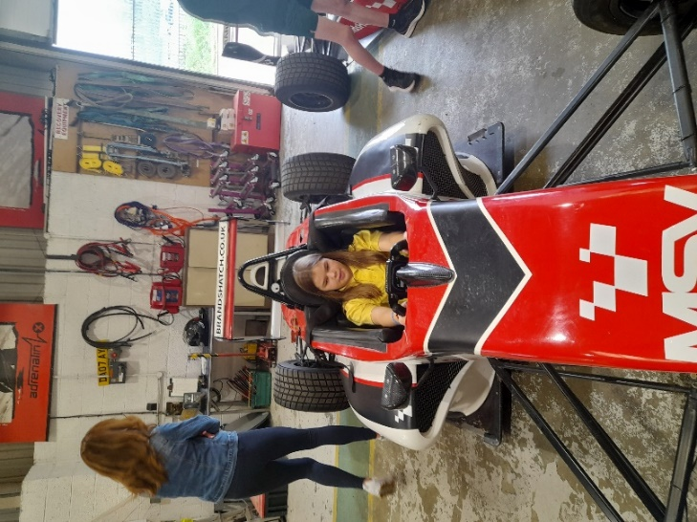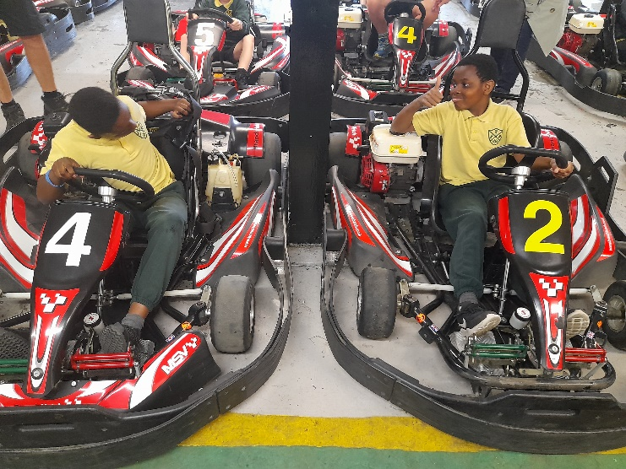

Kidzania Trip
Year 6 had a wonderful day trying out different careers at Kidzania!
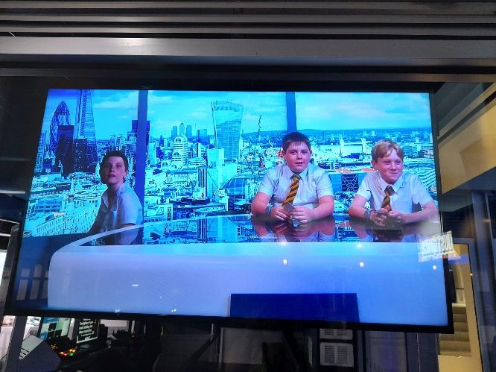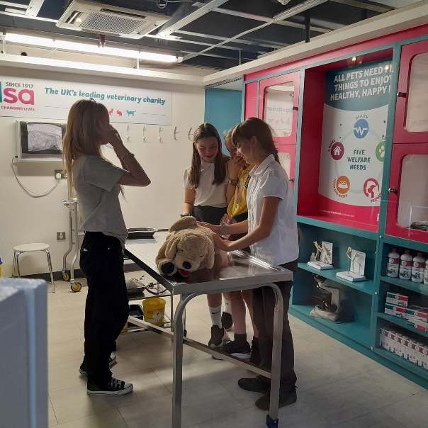

Lullingstone Trip
Owls Class visited Lullingstone Nature Centre to take part in pond dipping and learning about habitats.
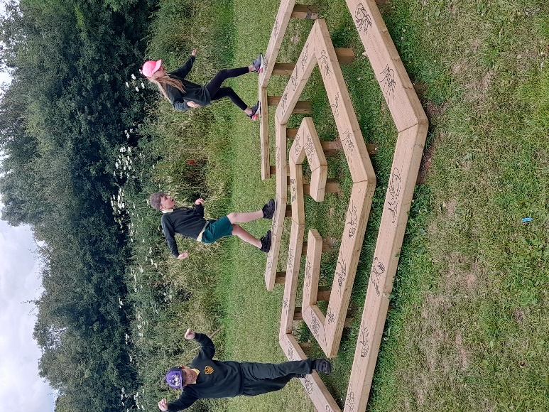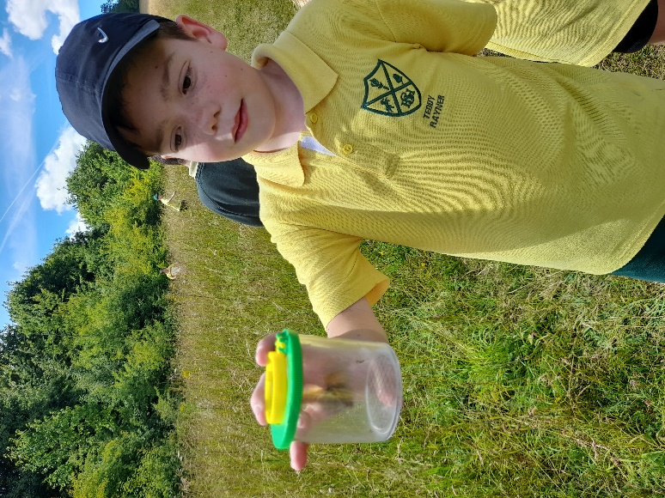

Isle of Sheppey Trip
Badgers Class visited the seaside as part of their coasts topic. They even found time for an ice cream!
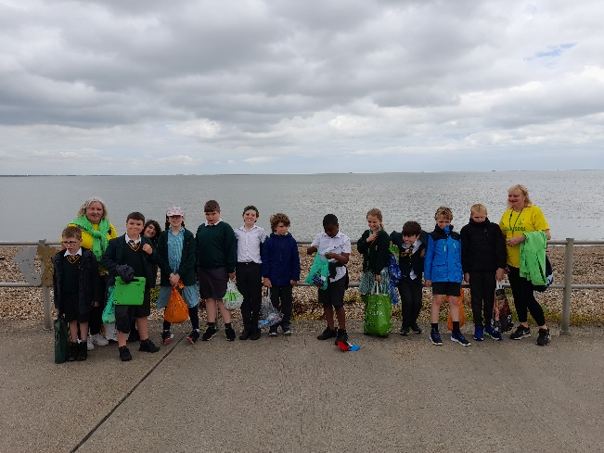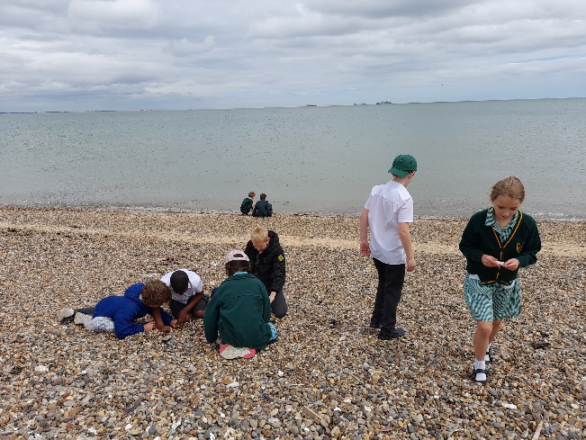

Howletts Trip
Rabbits Class visited Howletts Wild Animal Park as part of their topic on Safari.
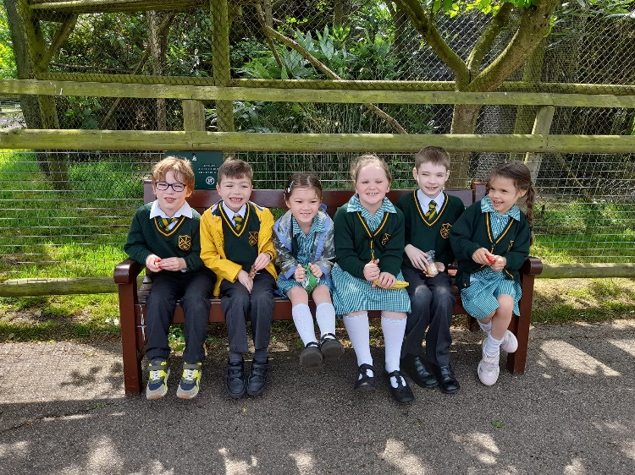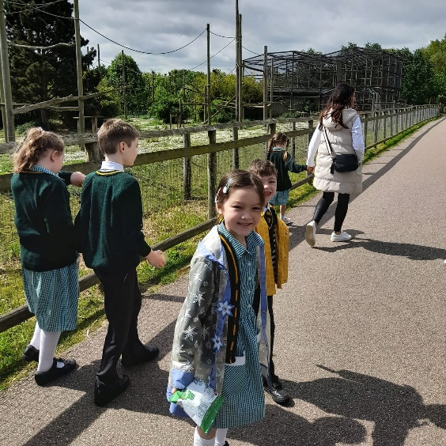

Platinum Jubilee
We had lots of fun celebrating the Queen’s Platinum Jubilee on Friday 20th May.
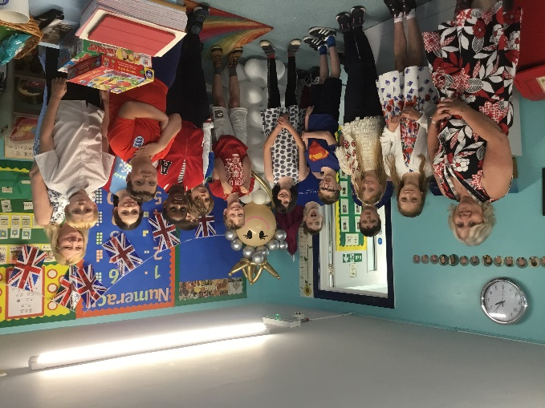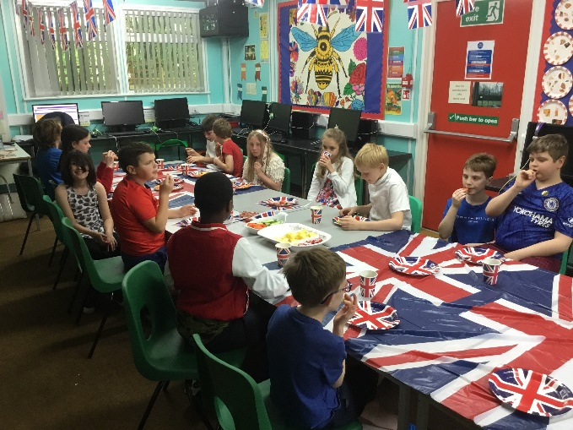
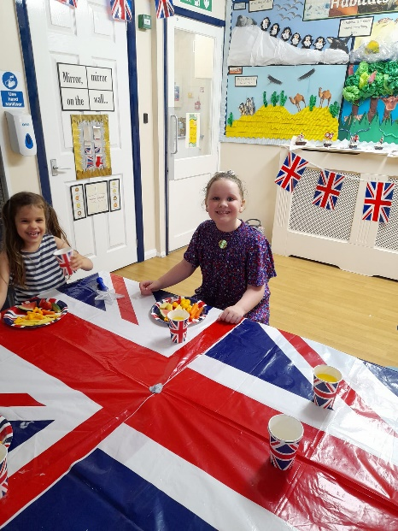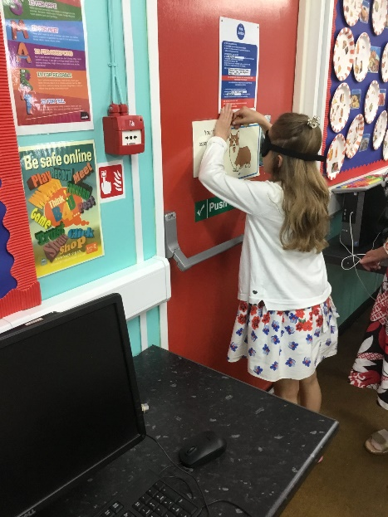

Summer Fayre
We had a great day for our Summer Fayre on the 24th June. The PTA raised a whopping £1,343!
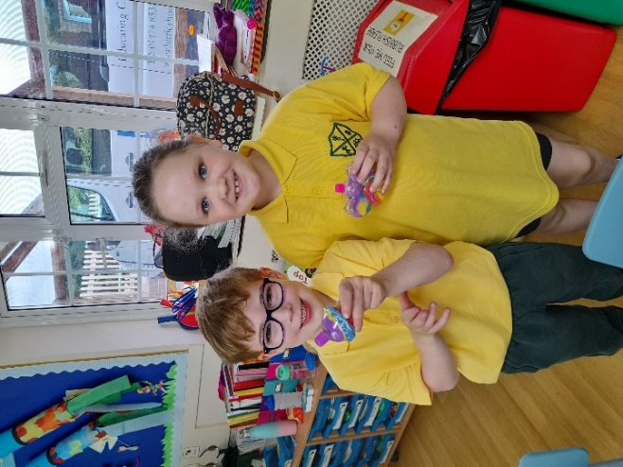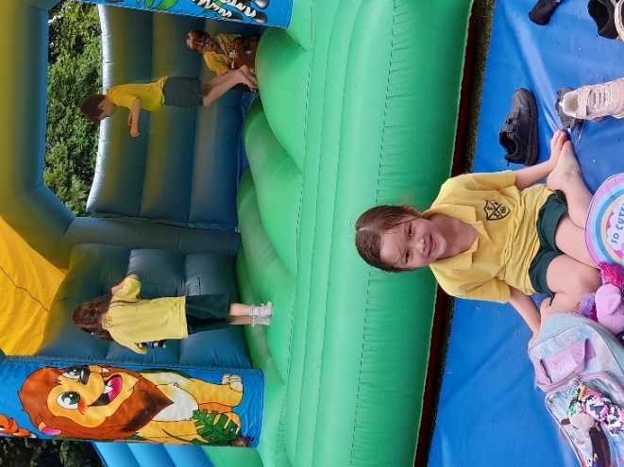
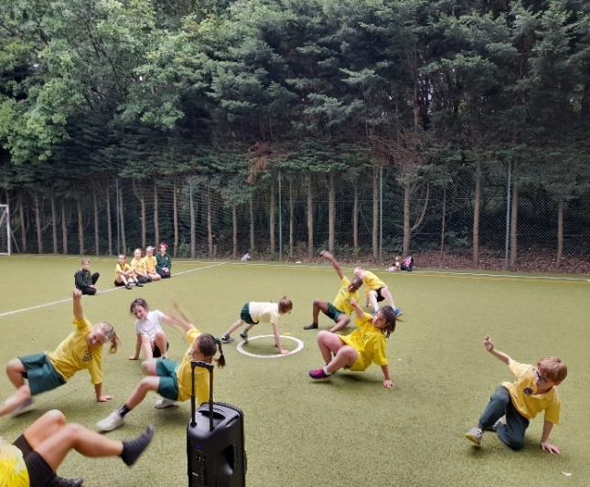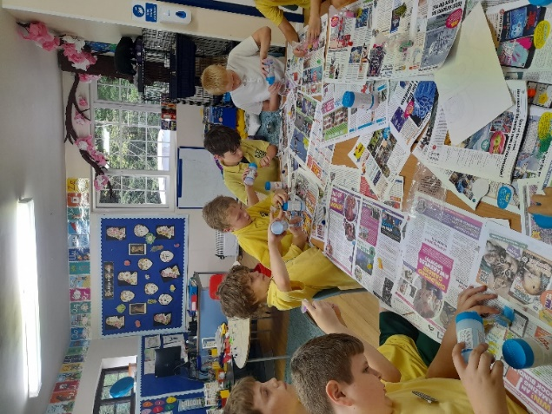

Summer School 2022
This is your last chance to book your place on this event. Please inform the office and transfer £50 online to the school account. Places were popular last year so don’t miss out! Mrs Sillitoe, Miss Whitehead, Lolly Sillitoe and Nick Wright will be staffing Summer School.
Summer School 2022 Monday 1st- Friday 5th August
(Your place can be secured with a £50 deposit)
Bank Details – Lloyds TSB – Sort Code – 30:93:60 Account Number – 30279168

Year 6 Leavers
We are very sad to see our Year 6 children leave us and want to wish them all the very best in their new schools:
Miles, Emilia, Maisie, Kenneth, Freya, Charlie, Khas, Hettie, Harry
WE WILL MISS YOU!!!

Mrs Sillitoe

Diary Dates
- Friday 8th July – New Classes Day
- Tuesday 12th July – Leavers’ Assembly 2pm for Year 6 parents only
- Wednesday 13th July – Open Afternoon for Parents 1.45pm
- Last day of Summer Term – Thursday 14th July at 2pm
- First Day of Autumn Term – Wednesday 7th September

Important
- Please note that from September, Mrs Sillitoe's name will be changing to Mrs Palmer. Children who currently know her as Mrs Sillitoe will NOT be expected to call her by her new name.
- REMINDER - Products containing nuts and sesame seeds are no longer permitted on school site due to a child suffering with severe allergies.

